Sign Language Recognition

Based On OpenCV

Anupam Yedida

Manipal Institute of Technology , Manipal , India.

[anupamy@gmail.com](mailto:anupamy@gmail.com)

1. INTRODUCTION

This paper discusses the recognition of letters from the American Sign Language (ASL) . Recognition is done using Contour Analysis and Feature Extraction techniques.

In the beginning the paper introduces the various algorithms involved in finding contours and OpenCV techniques . The project is coded in Python , using OpenCV Version 3.2.0.

1. SOLUTION: SETTING THE GOAL

The goal of this project is to design a program for extraction of human hand properties based on OpenCV. Implement proposed solution into desktop application with properly designed graphical interface and evaluate effectiveness of design.

1. THE ANALYTICAL CONSIDERATION

Even the most sophisticated machines are unusable when they are not controllable by human. The ideal interfaces must fullfill two requirements. They must be functional and usable. The design of such interfaces between humans and computers heavily depends on available technologies and target groups. Based on different criterions, it's possible to separate human-computer interfaces into several groups and these are visually based, audio based and sensor based.

The algorithm proposed in this paper falls between visually based interfaces. Human hand is seen by lens inside camera device and the image is converted into its digital representation. Digital image is nothing more than matrix of scalar or vector values (depends on whether the image is monochromatic or coloured) and it can be processed in numerous ways. That is where OpenCV library may be used, since it is optimized for such operations.

Contour of object is defined by set of points, which describe the edge of object, the outline. For example, the contour of tennis ball is circle. Numerous algorithms for finding contour in digital image were proposed and one of the first was proposed by Theo Pavlidis , where his algorithm is considered as base stone of all others. OpenCV library offers very efficient implementation of contour finding algorithm, which contains additional features like extraction of contours in hierarchy and approximation of found contours. Approximation of line contour with set of points is very handy feature and significantly speeds up further processing of contour. Such contour, represented as set of points, can be enclosed into n-dimensional polygon, also known as hull.

Hull, as the geometrical shape, can be concave or convex polygon. We can say that the hull is convex, when it is not possible to draw a line inside polygon which would intersect its border. If it is possible, then the polygon is not convex and therefore contains convexity defects.

These area descriptive properties will significantly help with design of algorithm since human hand does have huge convexity defects between fingers.

IV. SOLUTION AND RESULTS

1. *Creation of Threshold*

Creation of thresholded image is very crucial for Hand detection . Isolating the foreground from the Background is essential as we want the hand to be the region of Interest.

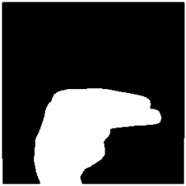

Figure 1. Thresholded Image of The Letter “H”

1. *Finding Contours*

The Hand is identified using an inbuilt function that finds Contours which OpenCV provides . The function is later then returns an array of co-ordinates of the formation of the Contour.

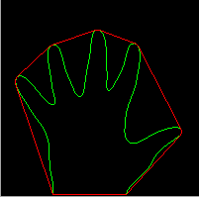

Figure 2. Contour of Hand with Convex Hull Identification .

*C. Convex Hull and Convexity Defects*

The data from the Contour Analysis is later manipulated to obtain an entity known as “Number of Convexity Defects”. Convexity Defects are irregularities in the contour . Based on the value of this , we can Identify how many fingers are present . This is valuable information as it provides information as to which Letter is corresponding.

The number of contour defects is calculated by the following process .

We compute a triangle . Let the sides be “a” ,”b” and “c” . This triangle is formed by the starting point of the contour , the ending point of the contour and the farthest point of the contour . (a , b , c respectively ) . “a” is computed as follows

a = math.sqrt((end[0] - start[0])**2 + (end[1] - start[1])**2) [7]

Similarly , b and c are also calculated .

Now, using the Cosine rule ,

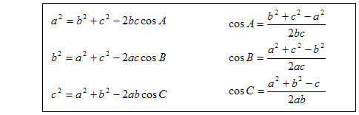

The angle A is calculated .

If the angle A is less than or equal to 90 degrees , it means that there is a convexity defect . Once there is a convexity defect recognised , a variable by the name “cnt” increments by one .

So , by this algorithm we can efficiently identify how many convexity defects there are .

1. *Identification of Letters*

**Letter A:** For identifying A , I computed the difference between the area of a circle and the area of the contour . The circle is obtained by bounding the contour . The reason this method is adopted for A is that there is very little difference between the two areas (mentioned above ) which makes the Letter A stand out from the other letters . Hence this algorithm was found to be very efficient .

**Letter B:** For the letter B , I computed the contour area . This method is adopted because the Letter B has the largest area among the other letters .

**Letters V, C, L, Y:** This part gets executed when the Letter A fails . If the number of convexity defects are equal to 1 , the following algorithm is employed .

The “angle” is calculated . This entity is obtained by an OpenCV inbuilt function that calculates the overall figure’s orientation , giving us an angle . Based on the values of the angle , Letters V , C, L and Y are identified .

**Letters F and W:** Letters F and W are the only alphabets in the American Sign Language to have 2 convexity defects . Once 2 convexity defects are identified , the angle is compared . Hence the Letters F and W are identified in this manner.

**Letters D, J, H, I, U:** A combination of parameters are computed to identify these letters ,

Solidity , Aspect ratio and Angles are computed .

On intensive testing of Contour Parameters , I found the above parameters to be reliable and efficient .

*E. Analysing Contour Properties*

Various Contour properties are computed to identify the letter made . They are listed as follows :

1. Aspect Ratio
2. Perimeter of Contour
3. Area of Contour
4. Equivalent Diameter of Contour Area
5. Solidity
6. Number of Convexity Defects
7. Angle
8. Bounding Rectangle Area
9. Moments

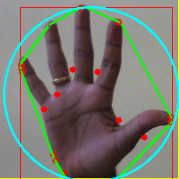

Figure 3. Analysis Of Hand with various methods .

1. *Audio Output Of The Identified Letter*

After the identification of a Letter , the challenge was to play an audio file which played “ The Letter is (Letter recognised)” . But once I played the audio file , it wasn’t getting completed . This is because the frame of the video stream keeps changing rapidly , not giving enough time for the audio file to finish . To overcome this problem , I made a bash script to handle the audio part . It’s working is given below .

Once a corresponding Letter is identified , I executed a function I defined . The algorithm is given as follows .

For example , The letter “U” is identified , I make a directory and navigate into that directory . Then a “.txt” file is made containing the “U”. If U already exists , it is overwritten .

Next , I wrote a Shell Script which goes into the directory and finds the last modified file , using its corresponding time stamp . Once the last modified file is found , The script plays the corresponding audio file . This approach doesn’t depend on the python program .

So the problem is solved .

*F . Types Of programs*

There are two programs . One for Consumers and one for Military applications .

Consumer :

People who are new to Sign Language and want to Learn in an interactive way , can make use of this program .Children who are born dumb can use this program to learn Sign Language .

Military :

Our Indian Army can use this program . Soldiers who are dumb can easily communicate with their base using this software .

The Military Program cannot be accessed by everyone . You must have a proper clearance for it . Username and Password is required .

.

V. CONCLUSION

The principal goal of this project was the design of the algorithm for tracking and extraction of features of object, specifically human hand in video based on OpenCV. 13 Letters are currently being able to be recognised . Further research into this project can be done.

The advantage of this solution is that it does not require any special inputs. Ordinary digital image of human hand is sufficient and algorithm can process stream of such images in real time.

REFERENCES

[1] <http://docs.opencv.org/3.0-beta/doc/tutorials/tutorials.html>

[2] <https://docs.scipy.org/doc/numpy/>

[3] <https://docs.python.org/2/library/tkinter.html>

[4] <https://www.pygame.org/docs/>

[5] <http://effbot.org/imagingbook/pil-index.htm>

[6] <https://pyglet.readthedocs.io/en/pyglet-1.2-maintenance>

[7] Python Module <https://docs.python.org/2/library/math.html>